Update customer profile - first cut
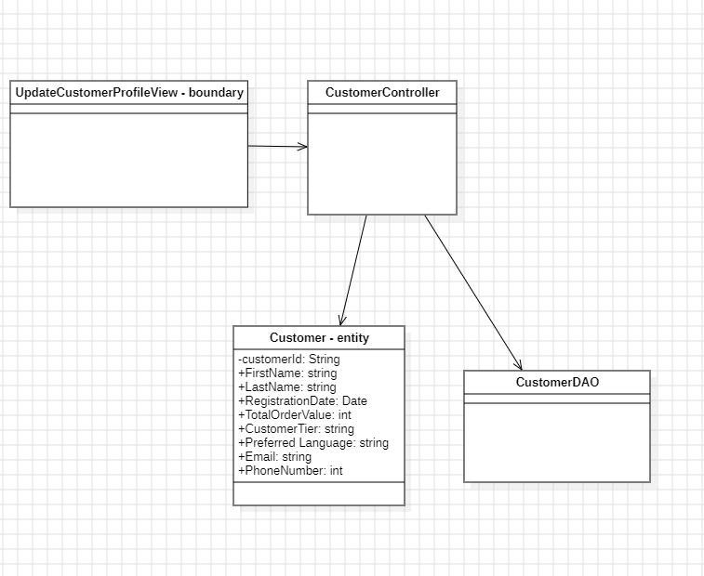

Customer Controller
Receive update request
Validate input
Delegate update

Customer
CustomerDAO
CRC:

Customer
Hold customer data
Apply profile updates

CustomerDAO

Customer DAO
Retrieve customer
Persist updates

Customer

DCD - final
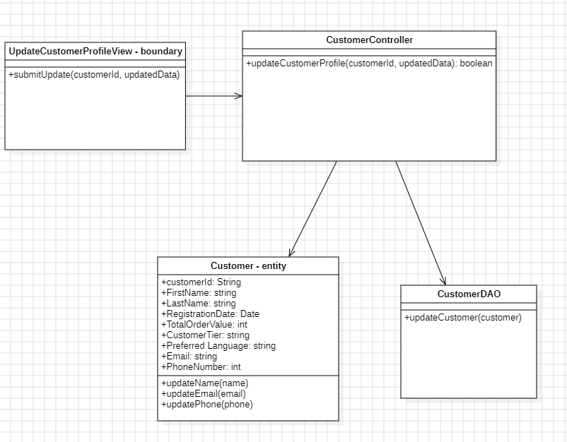

Generate customer summary
First cut
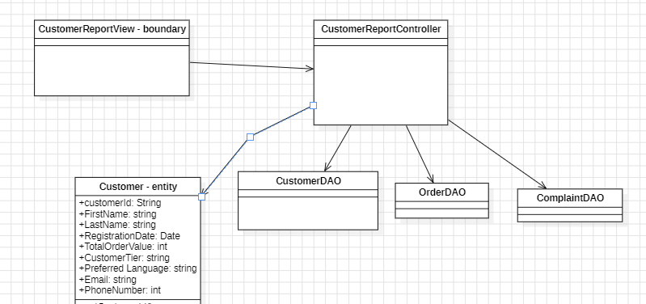

Final cut
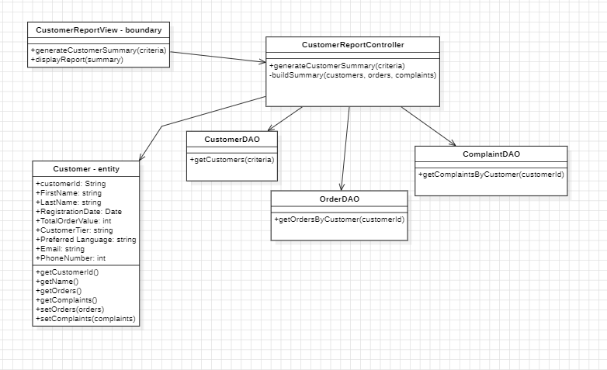

Communication diagram
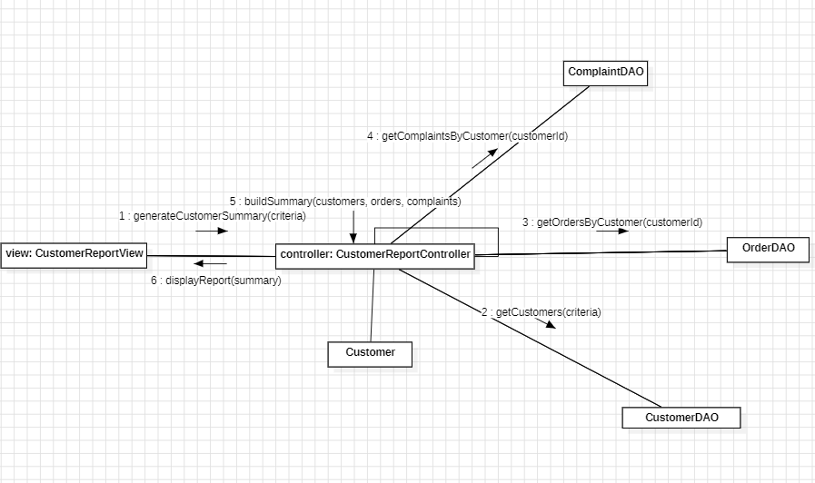

Generate Customer Segmentation Analysis
First cut
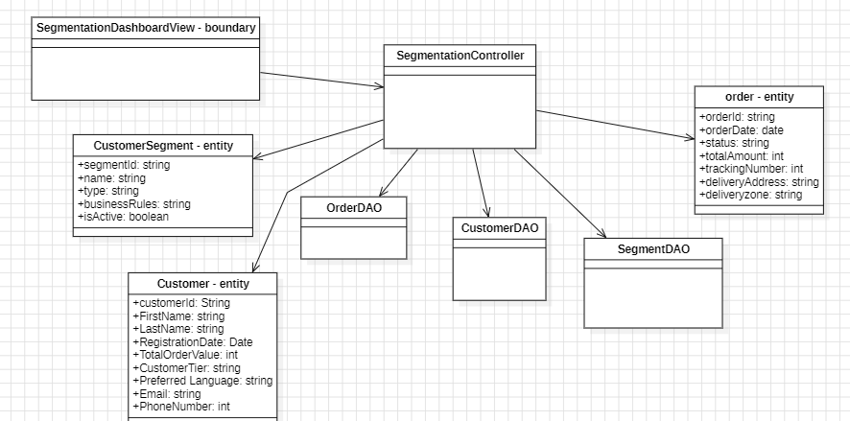

Final cut
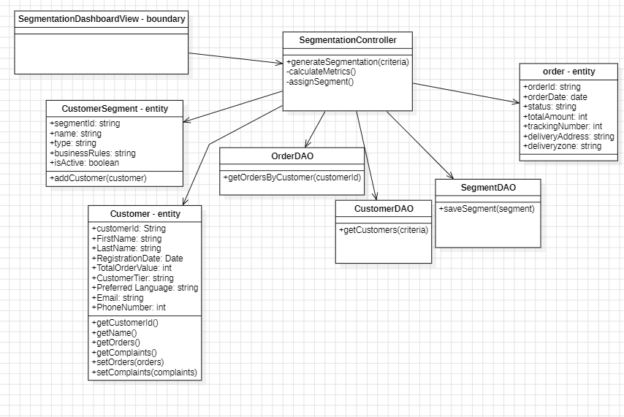

Sequence
